**2 in 1 Bluetooth A2DP Audio Music Transmitter & Receiver Aux 3.5mm Stereo Wireless Bluetooth 3.0 iPod Music Receiver Transmitter Adapter**

参考链接：

<http://www.ebay.com/itm/iClever-Bluetooth-Stereo-Audio-Music-Receiver-and-Transmitter-2-In-1-Adapter-/141357031328?hash=item20e9891fa0:g:KDUAAOSwYGFUvMbX>

* Bluetooth Transmitter: Turn your TV, PC, MP3 player, DVD player into bluetooth device to enjoy wireless music and sounds
* Bluetooth Receiver: Turn any speakers, headphones, stereo system into Bluetooth enabled
* Good compatibility that can work with any type and brand of audio source device. Easy pairing with bluetooth stereo audio enabled system.
* High performance Bluetooth 4.0 with A2DP for enhanced audio quality, allows you to enjoy the stereo music without wire restriction and watch TV without bothering family anymore, Up to 32 feet working range.
* Small, lightweight and durable, easy to carry it with you and you can enjoy Bluetooth music anytime/anywhere
* Super power and long battery life, it can be up to 8 hours as a transmitter and 6 hours as a receiver

**Product Details:**

Name:Mini Bluetooth 4.0 Receiver and Transmitter

Color:Black

Working time : up to 8 hours as a transmitter

up to 6 hours as a receiver

Charging time: about 2 hours

Bluetooth distance:10m

Charge input voltage: DC 5V

Frequency protocol: 2.402GHz-2.480GHz

Dimensions: 51X27X11mm

Weight:11.6g

**Features**

**Portable and delicate design**

Durable and easy to conduct panel , with 3 free cables to make it good compatibility , small size and lightweight allow it easy to carry , make it a good company in your life!

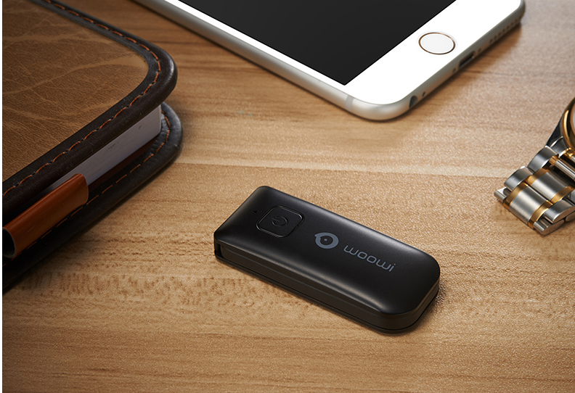

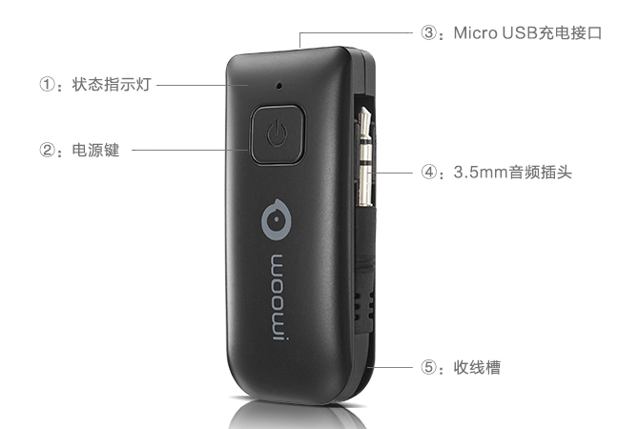

**A device can be used as transmitter as well as receiver**

Now with this device, you can turn your non-bluetooth audio device into bulutooth enabled device so you can enjoy wireless music in home stereo or car stereo as you like ,no more limitation, no more wires to mess up your space. Also , you can use it as a receiver to make normal headset into wireless bluetooth earphone to let listening music when running or taking bath more convenience,Now let this Powerful device save you from boring and nasty!

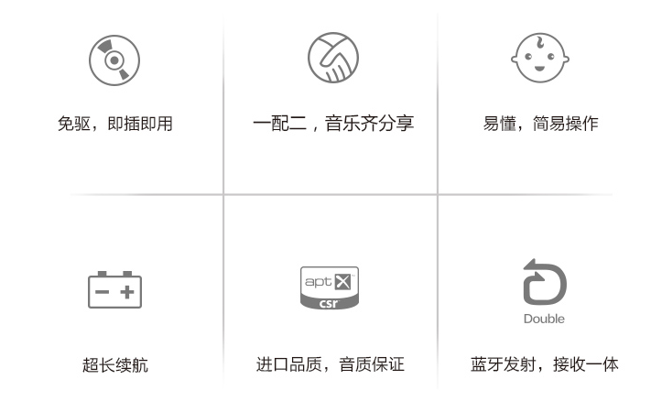

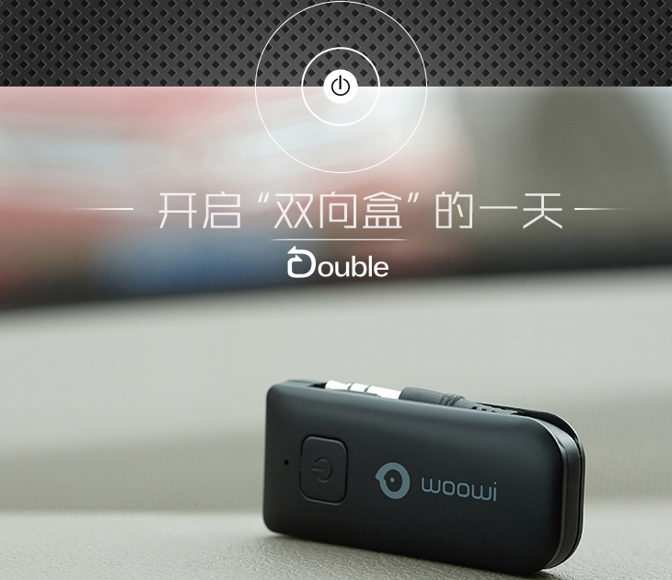

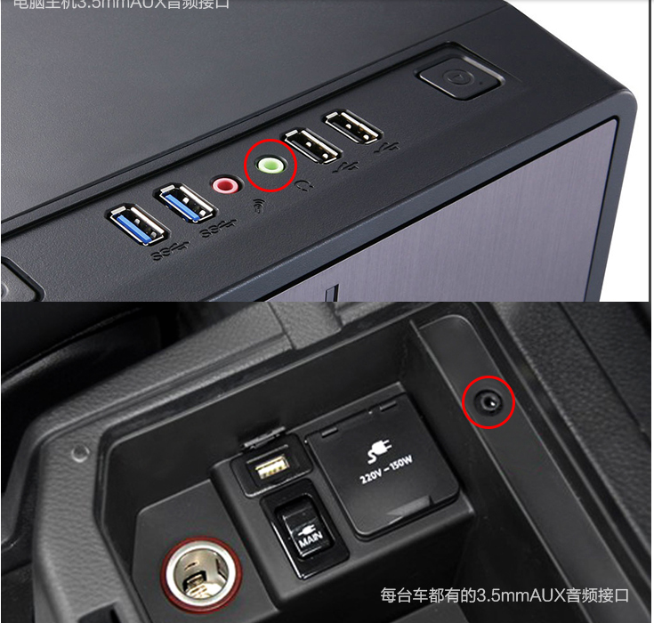

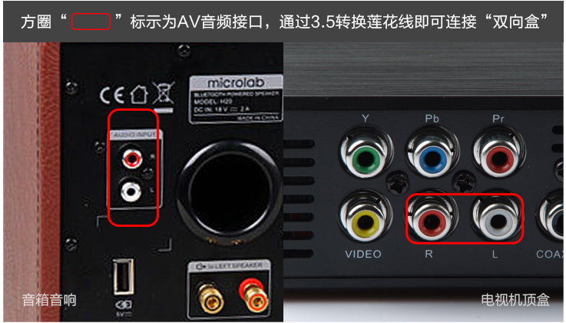

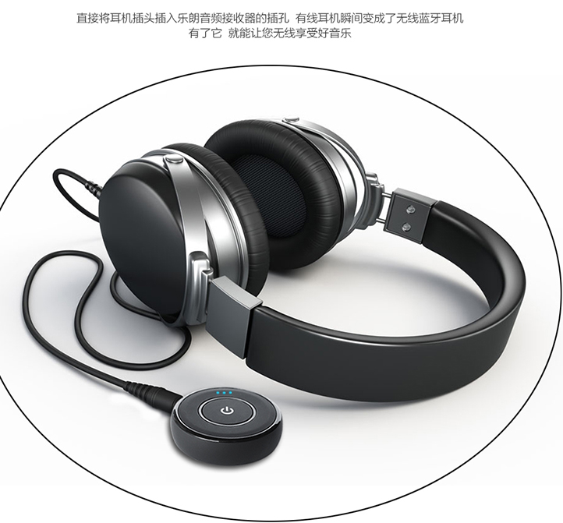

**Long distance and super power**

The distance between the devices is up to 30’(10m) when there are obstacles between them.and it can be up to 8 hours as a transmitter and 6 hours as a receiver

Image that you sleep in the couch to control the whole room’s audio system, this is amazing !

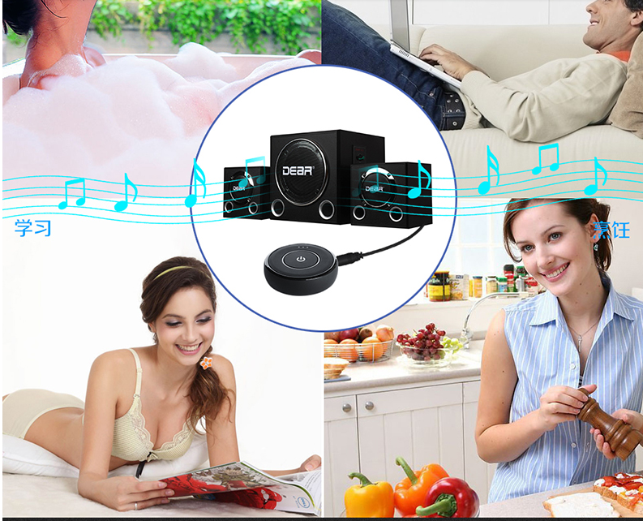

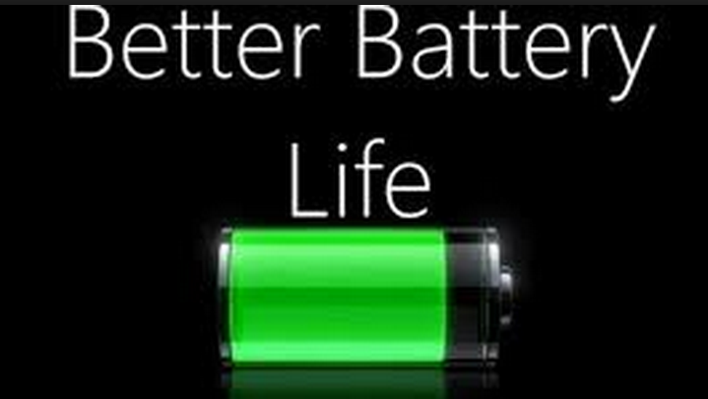

**Packing list**

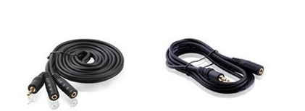

1. Bluetooth receiver and transmitter 1 pc

2.long 3.5mm audio line 1pc

3.short 3.5mm audio line 1pc

4.Charge cable 1pc

5.User manual 1 pc