1.Key Features
1, Intergrated with Bluetooth 4.0 and microphone makes it possible to phone hands-freely during driving. Additionally, the echo and noise reduction technology produces crystal clear sound.
2, It is designed with multiple functions integration makes operation the easiest especially ideal for people driving cars, you can control it by rotating or pressing the switch without staring at the button signs the conventional ones have.
3, Dual USB ports charger can charge additional device simultaneously, this extra USB can quick charge your device with up to 3A high current.
4, Works with almost all Bluetooth devices and all cars with an AUX input.
5, Voice Control: Siri function has been added to Bluetooth receiver, long press mufti-function switch will activate on your iPhone and you can make phone calls and send massage by voice control.

- Technical Specification
Chip Model: ACTS
Bluetooth Version: V4.0
Protocol Support: HSP, HFP, A2DP & AVRCP
Receiving Power: 0.175W
Effective Distance:≤10M
Working Frequency: 2.4GHz
Car Charger Input: DC 12V-24V (Vehicle power)
Car Charger USB output: 5V 3A max
BT Receiver Input: 3.7-5V
Car Charger Color: Black
BT Receiver Color: Black(Blue circle and silver button)
BT Receiver LED Color: Blue
Size: D4.4*H2.5CM
Weight: 40g

- Instruction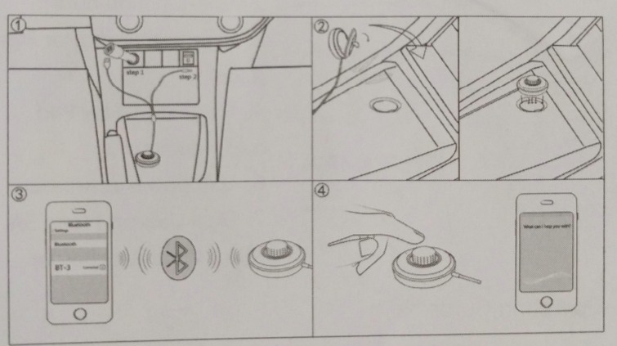
- Insert the car charger to the car cigarette socket, the power indicate lit up and the indicator flashes means it is ready to pair and then insert the 3.5mm audio plug into your car aux in port.
- Turn off the gum on the magnet and paste it on car’s place which you want, put the Bluetooth receiver on the magnet.
- Enable Bluetooth on your smart-phone in the settings, search “BT-3” and tap on it to start pairing, when successfully paired, the Bluetooth indicator will illuminate blue.

- Package
1xBluetooth receiver
1xDual USB car charger
1xUser Manual

Reference Link:
http://www.amazon.com/Bestfy-Bluetooth-Hands-Free-Rotatable-Adjustment/dp/B01CVLGC0M
http://www.amazon.com/LP-Bluetooth-Wireless-portable-lightweight/dp/B00UT0LXZC

