1.Key Features
1, This car windshield keeps your car interior away from 99.9% sun-ray and UV
2, Reduce in-car temperature while parking under the Sun.
3, Made it possible for your air-conditioner to cool quicker from parking under the Sun.
5, Easy to package as it able to be twisted to collapse into smaller size.
6, Lightweight, fold-able and easy to carry.
7, Easy to stick by provided suction cups and easy to put off with the pull ring.

It even comes with an extra USB port to charge your device simultaneously.
- Technical Specification
Material: Silver Plasters
Color: Silver (Front) + Black (Back)
Side Shades Size: Front: Approx. 65 x 38cm (L*W) Back: Approx. 44 x 36cm (L*W)
Front Shade Size: Approx. 150 x 70cm (L*W)
Back Shade Size: Approx. 100 x 50cm (L*W)
Weight: 300g

- Instruction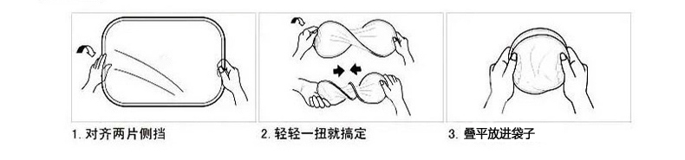
- Package
6 x Car Sun Shade
12 x Suction Cups
1 x Bag

Reference Link:
http://www.amazon.co.uk/Vktech®-6Pcs-Reflective-Window-Shade/dp/B00CJS2ZEA
http://www.amazon.co.uk/Windshield-Sunshade-Protect-Vehicle-Shading/dp/B00XL4IA1S

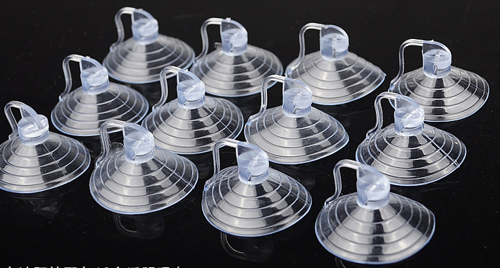
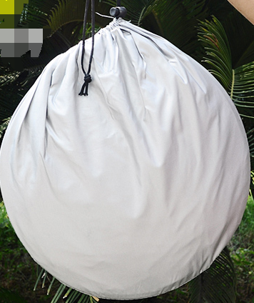
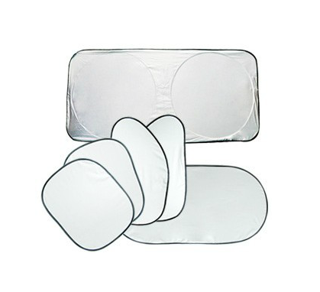

广告图例：
https://detail.tmall.com/item.htm?spm=a230r.1.14.61.gXjY6a&id=523236382044&ns=1&abbucket=11
https://item.taobao.com/item.htm?spm=a230r.1.14.43.VnVtYx&id=27345432846&ns=1&abbucket=11#detail&qq-pf-to=pcqq.c2c
https://item.taobao.com/item.htm?spm=a230r.1.14.9.8XC7HM&id=45681132507&ns=1&abbucket=11#detail
https://item.taobao.com/item.htm?spm=a230r.1.14.23.VnVtYx&id=25504848061&ns=1&abbucket=11#detail&qq-pf-to=pcqq.c2c
https://item.taobao.com/item.htm?spm=a230r.1.14.50.VnVtYx&id=23978908423&ns=1&abbucket=11#detail&qq-pf-to=pcqq.c2c

（注意，我们的前挡是带耳朵的）
