标题：Fascia frame for 178*100mm 2DIN headunit fit Corolla E120 2003-2006

适用车型：参考CS-W2302
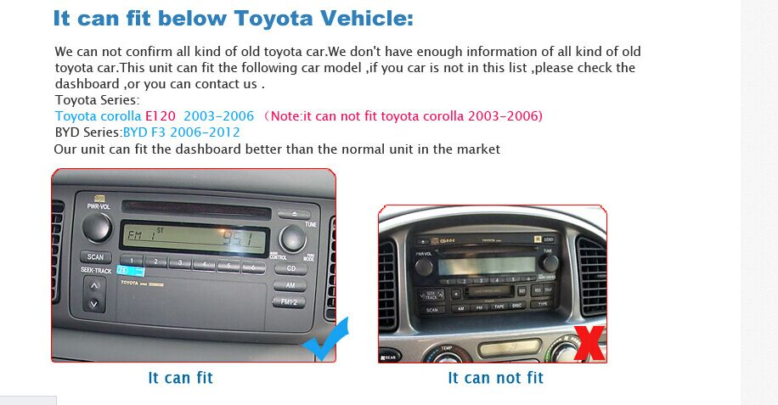
装车效果可以找RQ0255或者C0248来拍，标注框的内外尺寸

Fit the vehicle : Toyota Corolla E120 2003-2006 (please check the size of your factory radio carefully before purchasing .)

需要提醒客户：只支持面框尺寸是178*100mm的通用机 This frame dash kit can only fit the 2DIN universal headunit with the size 178*100mm .

