Grey Car Radio Stereo 2DIN Fascia Panel Refitting Frame Facia Trim Install Mount Kit For Skoda Octavia(2010~2013) Manual A/C

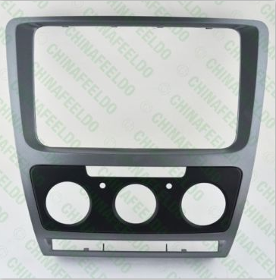

Material Type:ABS
Available Color:Grey
Placement:Dashboard

Special For The Following Vehicle Dashboard:
Skoda Octavia(2010~2013) 2DIN Size With Manual A/C

