Operation Manual
PICTURE:
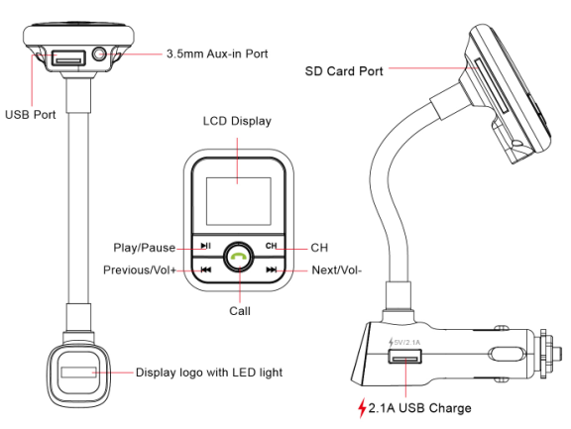

FEATURES:

- Wireless transmit phone call from Bluetooth mobile phone to the car FM stereo system.
- Built-in FM transmitter, full frequency: 87.5-108.0MHZ.
- With built-in microphone and automatically calling-number system
- Supports USB disk and SD card,A2DP function
- With 3.5mm line-in jack, support external audio devices.
- Switch to Hands-free mode automatically from music playing status when receiving calls
- Supports 4 loop modes: Repeat all, Random, Repeat one, Folder,
- 5 EQ for optional: Natural, Rock, Pop, Classic, Jazz
- USB charging port for charging iPod/ iPhone, iPad and other mobile device. (output: DC 5V/2.1A).
- Support 12-24V voltage from the car cigarette lighter.
- Strong and elegant design with LCD screen display, just support number displaying.
- Flexible metallic hose adapted for any type of autos.
- With infrared remote control, easy operation

Using FM Transmitter function:
- Plug the FM transmitter into your vehicle’s cigarette lighter or power port.
- Tune your radio to an unused FM frequency, then match the same frequency of this unit.
- Insert a USB flash drive or SD card which containing MP3 files into USB port or memory card slot of this unit accordingly. It will play and transmit the MP3 files automatically.
- Line-in function: Use the provided audio cable to connect an MP3/MP4 players or another external device to the AUX input of this unit. When using this function, please stop playback of USB or memory card, and all functions will be controlled by the external device.

Using Bluetooth function:

1. Using Bluetooth for the first time, you need to pair your mobile phone with this unit. Activate your mobile phone's bluetooth function, then search new device. When the mobile phone detects this unit (named as "BT67"), please pair and connect by using the original password "0000"
2. In the music playing mode, when there is an incoming call, this unit will automatically switch to telephone mode.
Note: The Bluetooth indicator light which on the top of the screen will be stop flashing after the Bluetooth connected with your mobile phone.

Bluetooth calling:

- Please press the red "Answer/Hang off" button in the middle of the keyboard to answer the incoming call.
- Please press the red "Answer/Hang off" button in the middle of the keyboard to hang off a call.
- When making a call, you can only dial the phone number by your mobile phone, but once the call connected, you can use the hands-free function to enjoy it.
Note: The Bluetooth indicator light which on the top of the screen will be flash quickly when talking.

Using USB charger function:

When this unit powered from car lighter socket,
connect the USB Charger port to your mobile phone
with a special USB cable (not included).
This unit will serve as mobile phone charger.

Remote controller:
Most of the function can be fulfilled by the remote controller provided.

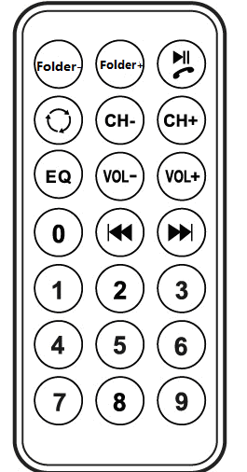

Quick Guide:

Operation Guide | On FM transmitter | On Remote Controller
1. Answer / hang up the call: | Press "answer/hang off " button: answer the call  Press "answer/hang off" button: hang off the call | Press” ”button
2. Play and Pause the music: | Press “” Button: Play the music  Press “” Button again: Pause playing | Press Button
3. Adjust the Volume: | Press and hold “” button: Increase Volume  Press and hold “” Button: Decrease Volume | Press “vol+” to increase the Volume；Press “vol-” to decrease the Volume；
4.Set frequency: | Press “CH” button first, then  press “”: increase the frequency  Press ””: decrease the frequency | Press “CH+” button: Increase 0.1MHz  Press “CH-” button: decrease 0.1MHz  Or press the numbers of the frequency what you desired, press “CH+” to confirm.
5. Choose music: | Press “” Button: Play the next song  Press “” Button: Play the previous song | Press button: Play the next song; Press button: Play the previous song;  Or press the number of the song then press to confirm
6. Choose EQ: | Support by remote controller only | Press “EQ” button to choose your favorite EQ
7. Switch folder: | Support by remote controller only | Press “folder” button to switch folder
8. Loop mode: | Long press “play/pause” button, four loop modes optional: folder, single, random, all | Press “” button

SPECIFICATIONS:

BLUETOOTH IC: CSR BC8635 Stereo (CSR 4.0)
Frequency: 87.5-108.0 MHZ
Frequency Stability: ±10ppmI (0℃-+45℃)
Output Frequency: 20HZ-20KHZ
Supply Voltage : 12-24V
USB Charger output: 5V/2.1A
Music Format: MP3 Format
USB (Maximum support): 32GB
Micro SD (Maximum support): 32GB
Transmit Distance: >10M
Operating system: Win xp/Win vista/Win7
MP3 S/N RATIO: 60-70dbm
MP3 BITRTE: 32KPB-320KPBS
SNR:≥80dB

