1.Key Features
1, Suitable for most tires of bike, motorcycle and car.
2, 4 measurement units:PSI,BAR, KPA, Kg/cm2
3, Replaceable coin batteries.
4, To save gas and keep tire wear with proper inflation.
5, Automatically shuts off after 29 seconds to save battery life
6, 9 in 1: Digit-Tire gauge, Glass breaking hammer, Seat belt cutter, flashlight, Scissors, Plier, Phillips screwdriver, Slotted screwdriver, LED light
- Technical Specification
Material: Metal and Plastic
Color:Black and Silver
Power Source: CR2032*1(included) AAA*2(Not included)
Working temperature range: 30~122 degrees Fahrenheit (0~50 Celsius)
Measurement range: 3~150 PSI
Accuracy: ±1PSI
Body Color: Black
LED Color: Red
Flashlight Color: White
Size: L17.5*W4.8*D2.8CM
Weight: 177g
- Instruction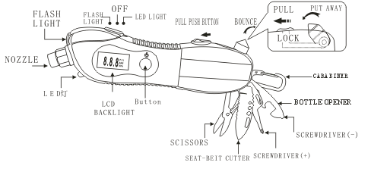
1, Simply press the "ON" button once to turn on the gauge
2, Press firmly against auto valve stem
3, Your Tyre pressure is instantly displayed and stays on screen for 29 seconds after reading and by repeatedly press the "ON" button it allows you to change measurement as PSI, BAR, KPA or kg/cm².

- Package
1xDigi-Tyire Gauge
1xUser Manual

Reference Link:
http://www.amazon.co.uk/DBPOWER-Emergency-Tool-Safety-Flashlight-Automotive/dp/B011NMCH9A
http://www.amazon.co.uk/MaXinDa-emergemcy-Seatbelt-Flashlight-Sicssors/dp/B01CI1BVL0

