第一张
9" DIGITAL TFT LCD HEADREST DVD PLAYER MONITOR
Built in IR/FM Transmitter/USB/SD/Wireless Game Disc(1 Piece)
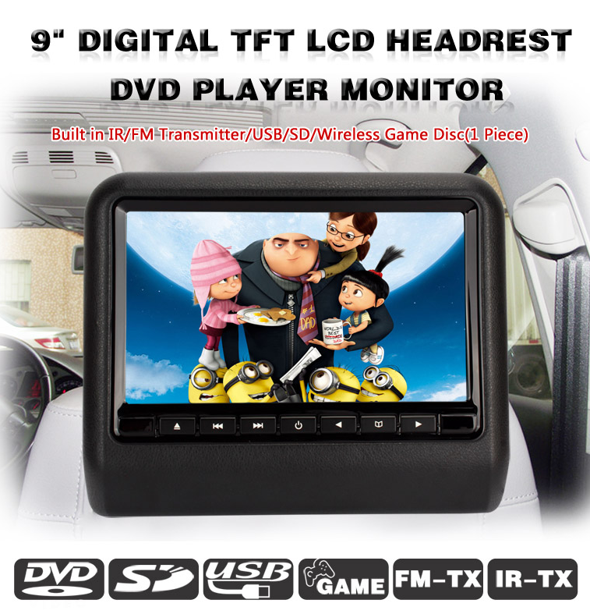

第二张
Screen Resolution

The 9 inch high resolution color TFT LCD display brings images to life, showing off your treasured photos, favorite movies and music with the same “real life” rich detail and vibrant colors as high quality prints.

Digital Screen Resolution: 800*480
Analog Screen Resolution: 480*234
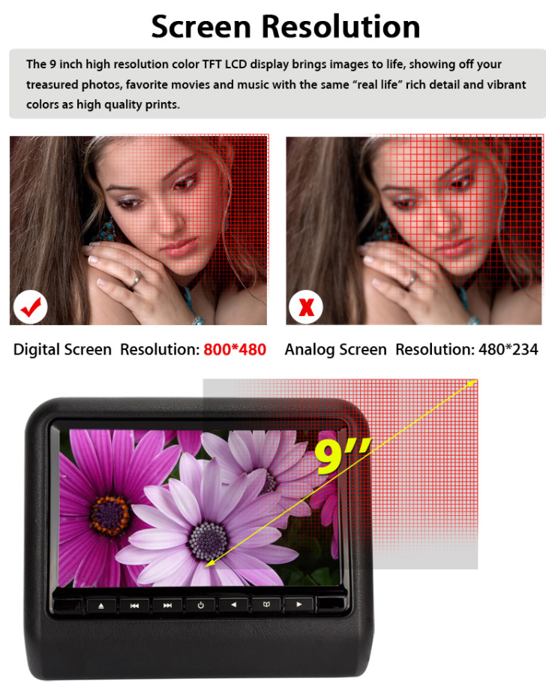
第三张
Multimedia

Audio Menu Language:
English, Deutsch, Spanish, French, Portuguese, Latin, Japanese

Subtitle Language:
English, Spanish, French, Portuguese, Latin, Japanese

DVD Player
The headrest built in DVD driver which can compatible with most DVD and CD discs available in the market (Except Blue-ray and some HD discs)

DVD-R DVD-RW DVD+R DVD+RW
VCD SVCD CD-R CD-RW Picture CD

Disc Insert Direction
Disc Entrance

USB/SD
Built in USB/SD slot for direct plugging, support up to 16GB capacity, compatible with Mp3/Jpeg/Mp4/Divx up to 480P, enjoy the super convenience control of the headrest.

USB 2.0 Port:
Plug in your USB stick to quickly add or remove media.

Standard SD Card Slot:
Insert your SD card to play stored music and photo files through display.

Max Support 16GB

USB Slot
SD Slot
Headphone
AV IN
Power
DC
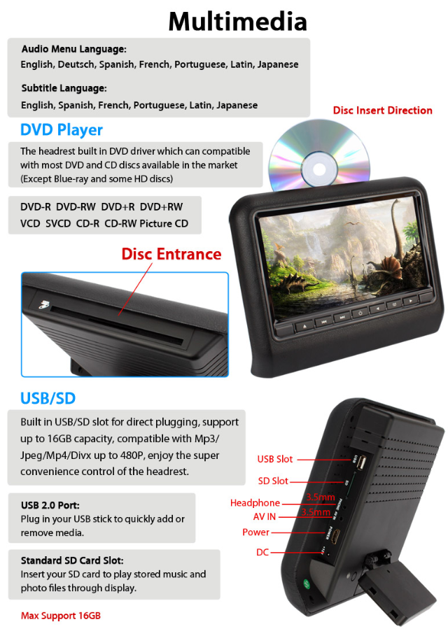
第四张
Support 32 Bits Games

Standard include 1 piece game disc which content some classic games, and 1 game remote for playing.
Note: Not all game discs are compatible with the headrest.

FREE

(Require 2*1.5V AAA Battery)
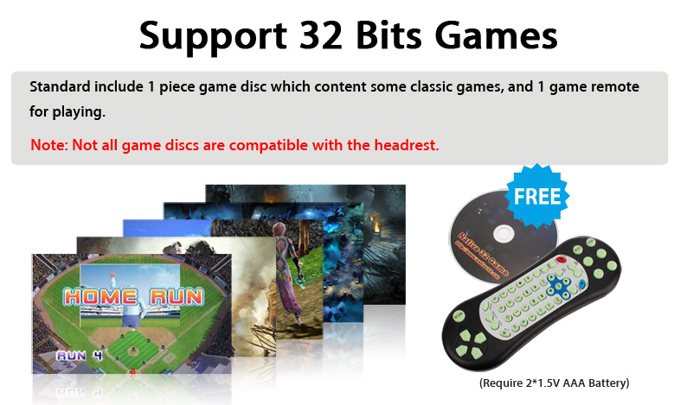
第五张
You Have Multiple Choices for Soud Out

FM-TX:
Listen to the music or audio from the movie playing on the headrest. FM transmits your music or audio over the strongest FM frequency available. The FM transmitter will send the clearest signal at the push of a button, with no special installation or wiring. So you get stereo sound for your playing list or movies.
(Apply to Radio player Only)

IR-TX:
This unit consists of an infrared receiver and infrared transmitter is idea for receiving sound within the car. The transmitter can be quickly connected to any IR devices, like IR headphones. By sending out infrared light signals from the transmitter to the IR headphones, you can listen to music cordless.
(Apply to IR receiver device Only)

Choice 1:
Built in IR Transmitter
The IR transmitter allows you to enjoy the audio files with wireless headphones.Supports dual channel(A&B) wireless infrared headphones.
A: 2.3-2.8MHz B:3.2-3.8MHz

Choice 2:
Built in Speakers
Play audio directly from the unit
Note: when you open IR/FM transmitter the built in speakers will be muted。

Choice 3:
The built in FM transmitter can send the audio signal from the headrest to the other radio
receiver (such as car stereo), then you can share the audio with other people.
8 available Frequencies
87.7 88.1 88.5 88.9 106.7 107.1 107.5 107.9
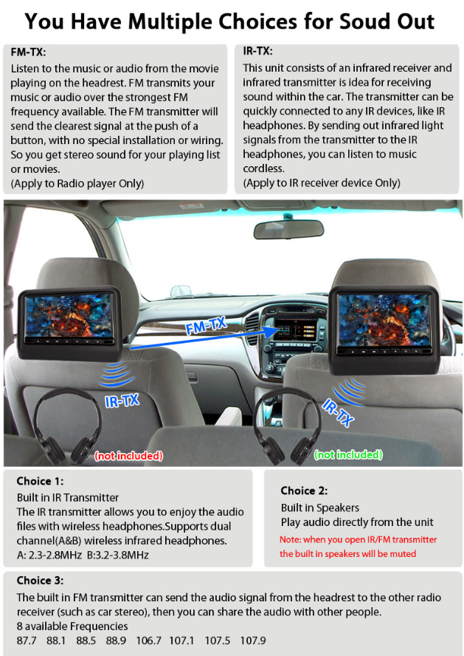
第六张
AV-IN/AV-OUT

Support video signal input&output.

Not Included

AV-OUT
AV-IN
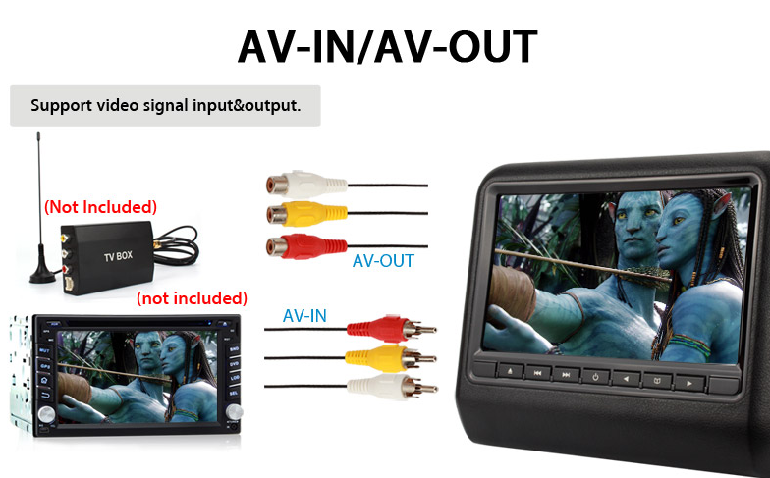
第七张
About The Device

OSD Language:

Button:
1. Infrared receiver window
2. Enter/Eject discs
3. Move previous
4. Move next
5. ON/OFF/Function switch
6. VOL down
7. Menu(Long press)
8. VOL up

Dimension:

Installation Instruction:

Two Ways for Power Supply :

1. Plug in cigar lighter socket (Adaptar provided)
2. Connect to 12V power(Power Cable provided)
12V DC
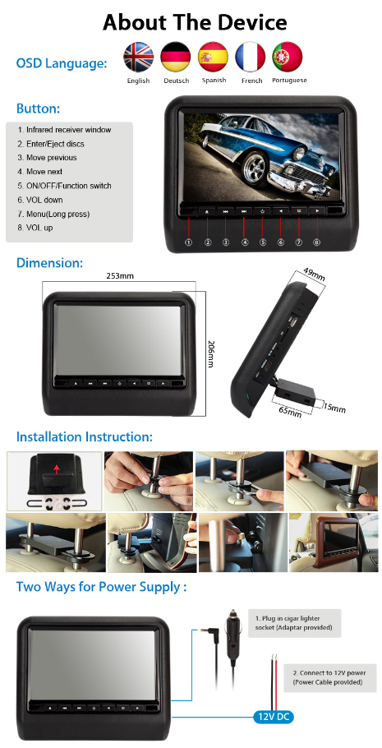
第八张
What’s in the package box

All-in-one Cable 1.8M
Plug Adapter 0.2M
Plug Adapter 0.2M
Cigar Lighter Power Adapter 2M
Fixed bracket 4 pairs
Remote Control (without battery)
Game Disc 1 piece
English Manual
Fix Screw
DVD Player Monitor

